Lab 10: Generating e-mail content
Estimated Duration: 20 minutes
Lab Type: Instructor Led
Introduction
When a prompt is given, the Azure OpenAI model will return one or more predicted completions, and can also return the probabilities of alternative tokens at each position.
Objectives
- To generate an e-mail response using Azure AI Studio gpt-35-turbo model in Visual Studio code.
Important: You can proceed with this lab only if your request for the Azure OpenAI Service has been approved. Please look for an email in the registered email id for Onboarding. If it is not approved, you can put this and the next labs(Labs 10 and 11) on hold until you get access and continue with Lab 12.

Exercise 0: Install the required libraries

Task 1: Install Python
- Open your browserand navigate to https://www.python.org/downloads/
- In the Python window, click on Python 3.11.4 or later version.
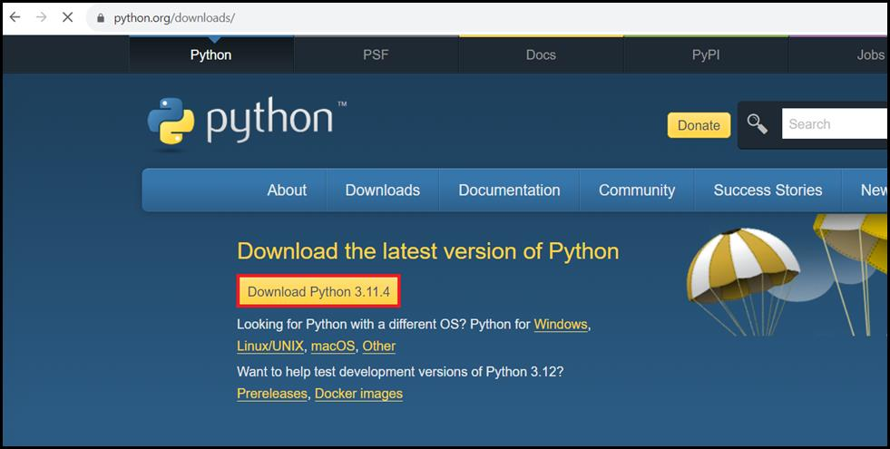
- python-3.11.4-amd64.exe file will be downloaded. Click on the downloaded file to install the Python software. (In case, you did not find the python-3.11.4-amd64.exe file on your window, then navigate to the Downloads folder of your system and continue the installation process).
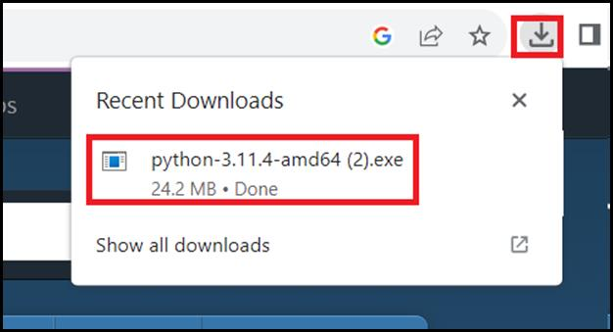
- In the Modify Setup window, click on Modify.
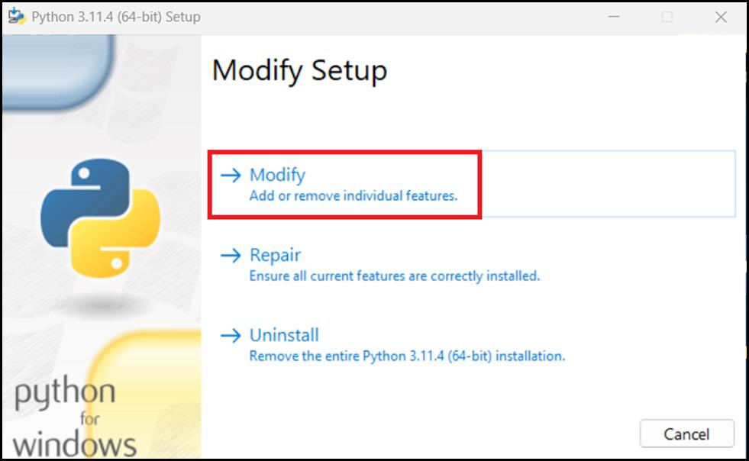
- Leave the Optional Features window in the default state and click on the Next button.
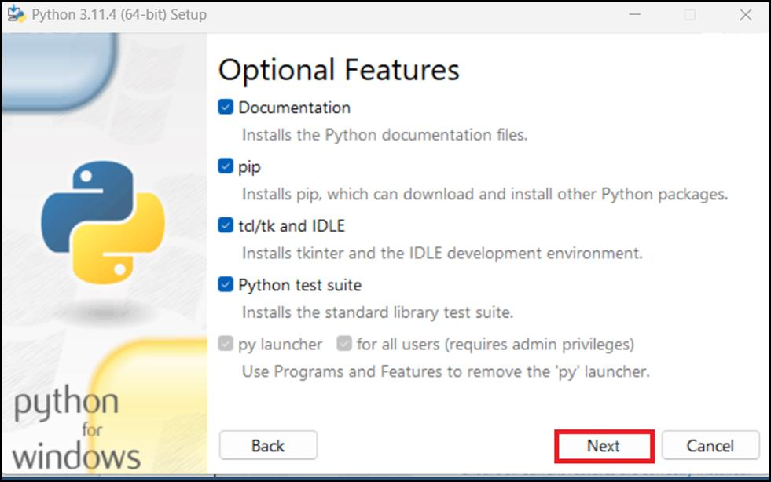
- In the Advanced Options window, click on the Install button. If you see the dialog box - Do you want to allow this app to make changes to your device? then click on the Yes button.
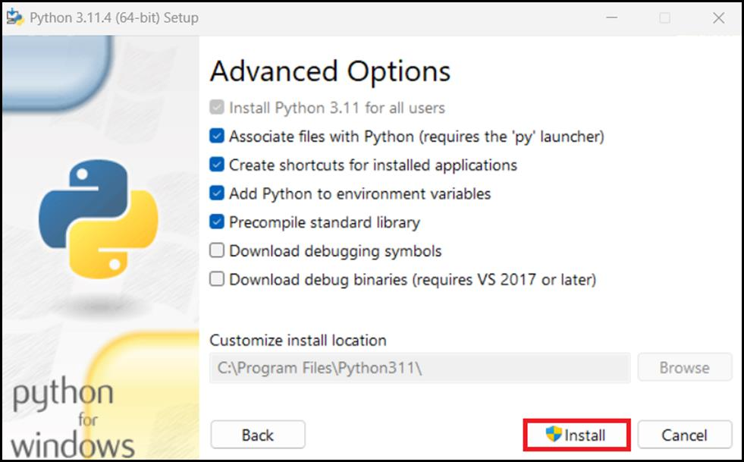
- In Modify was successful window, click on the Close button. You have successfully updated the Python software.
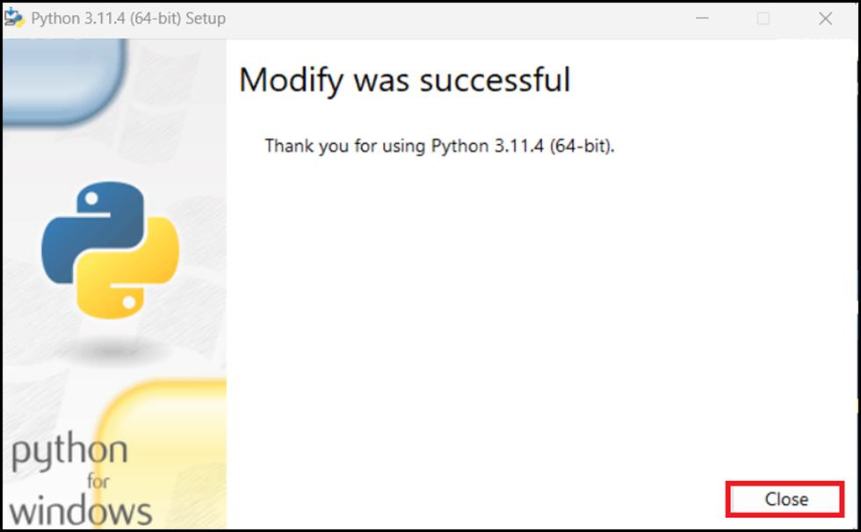
- In your windows search bar, type Command Prompt. In the Command Prompt App dialog box, navigate and click on Run as administrator. If you see the dialog box - Do you want to allow this app to make changes to your device? then click on the Yes button.
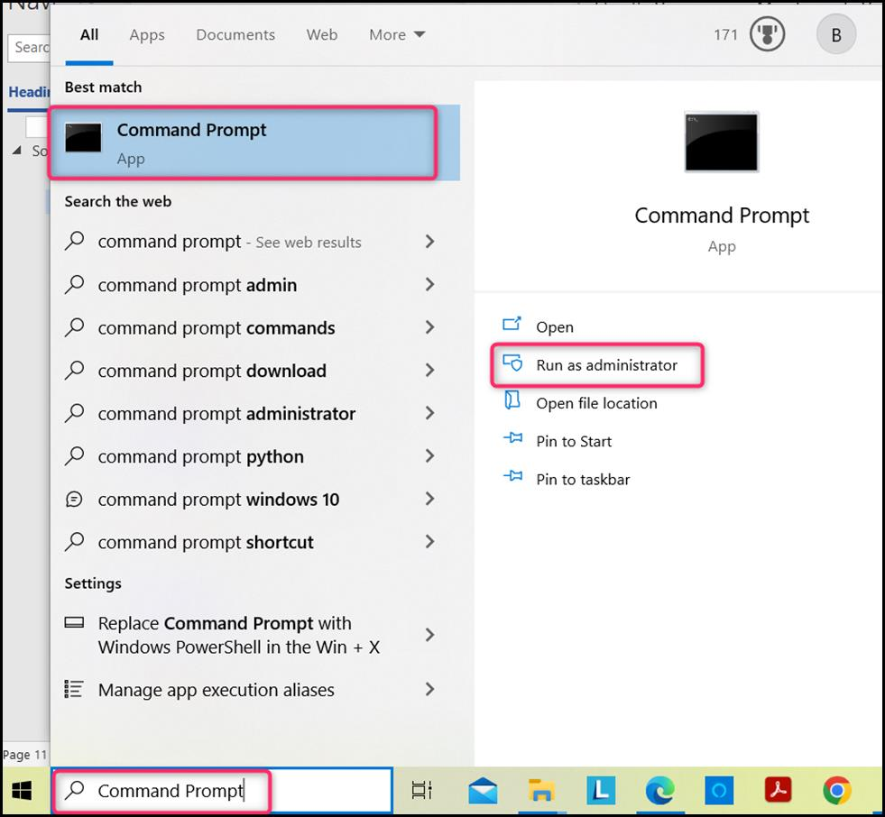

Task 2: Update Python Libraries
- Move into the folder where the Python was installed and run the pip command.
cd\
cd Program Files
pip
python -m pip install --upgrade pip
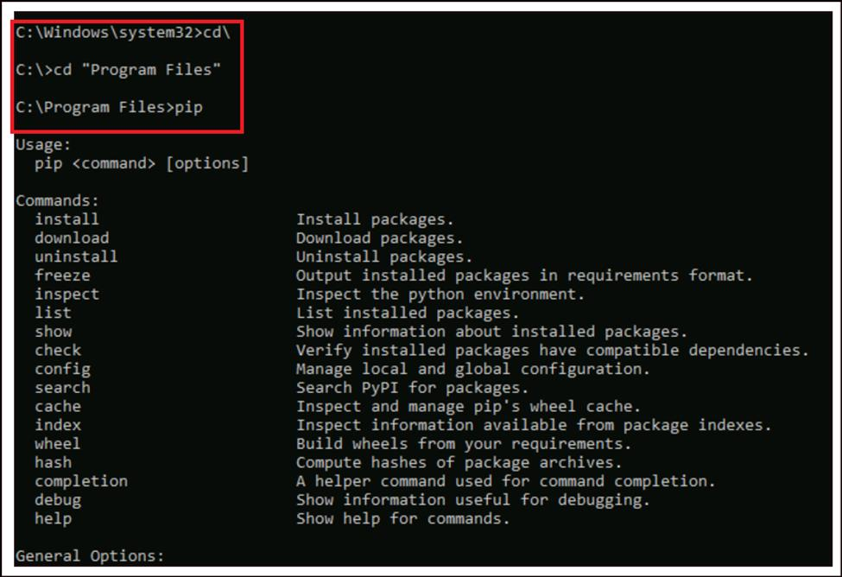
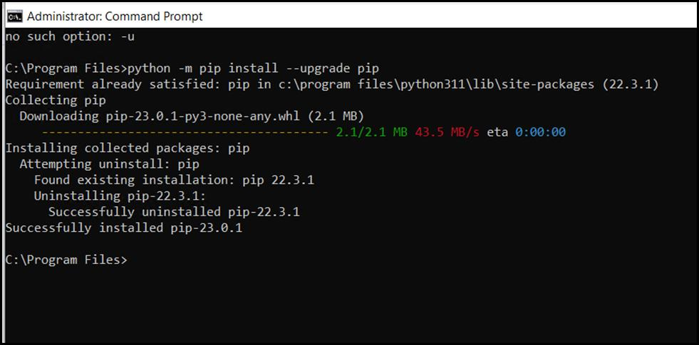
- Run the following command to install Python libraries - openai, num2words, matplotlib, plotly, scipy, scikit-learn, pandas, tiktoken
pip install openai num2words matplotlib plotly scipy scikit-learn pandas tiktoken
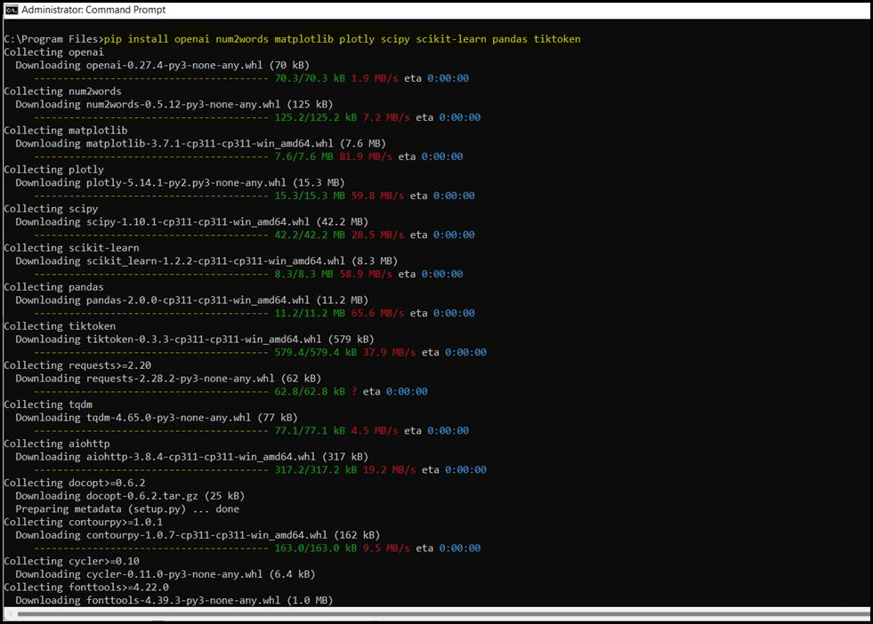
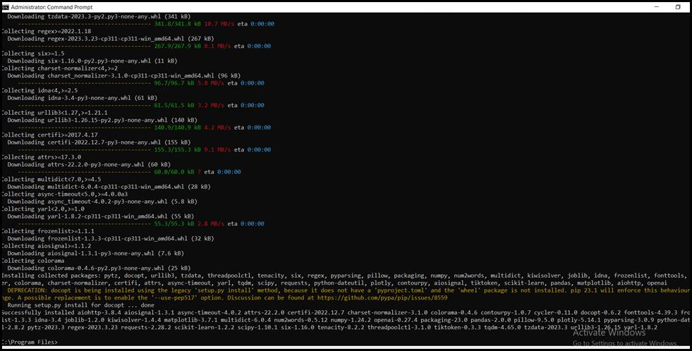
- Install the Transformers package with the following command:
pip install transformers
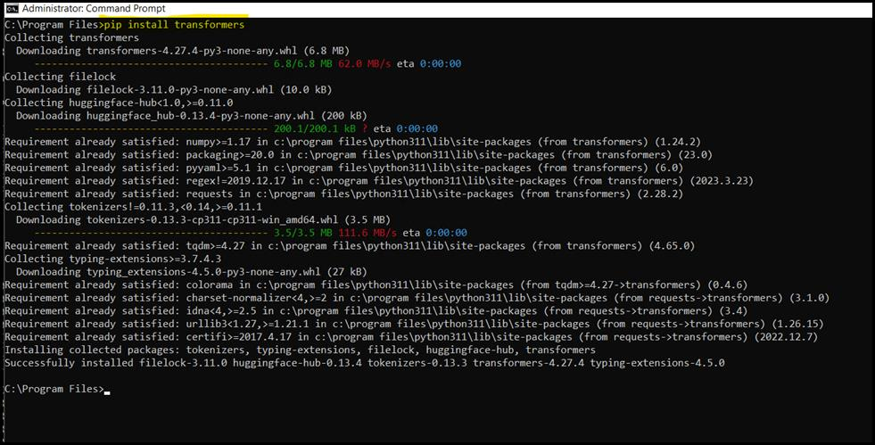

Task 3: Install Jupyter
- Open your browser and navigate to the URL: https://jupyter.org/.
- In the Jupyter window, click on the Install tab.
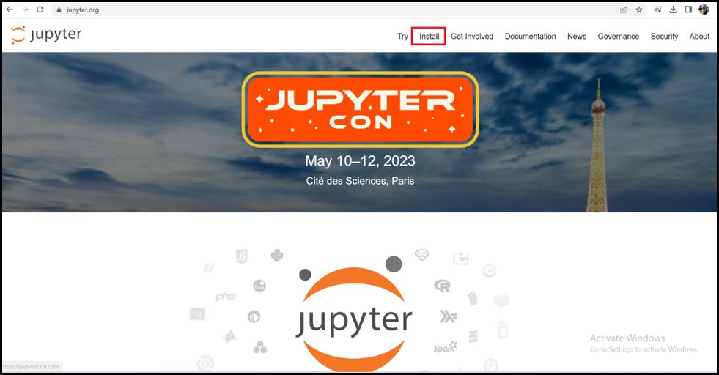
- Install JupyterLab with the following command:
pip install jupyterlab
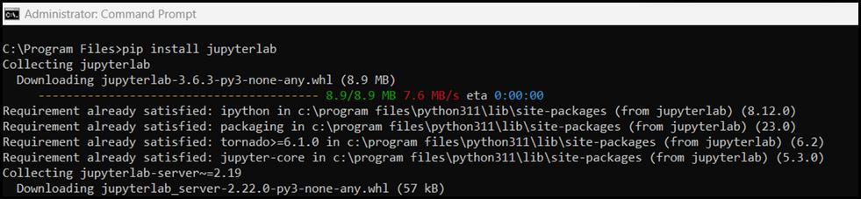
- After installation, launch JupyterLab with the following command:
jupyter-lab
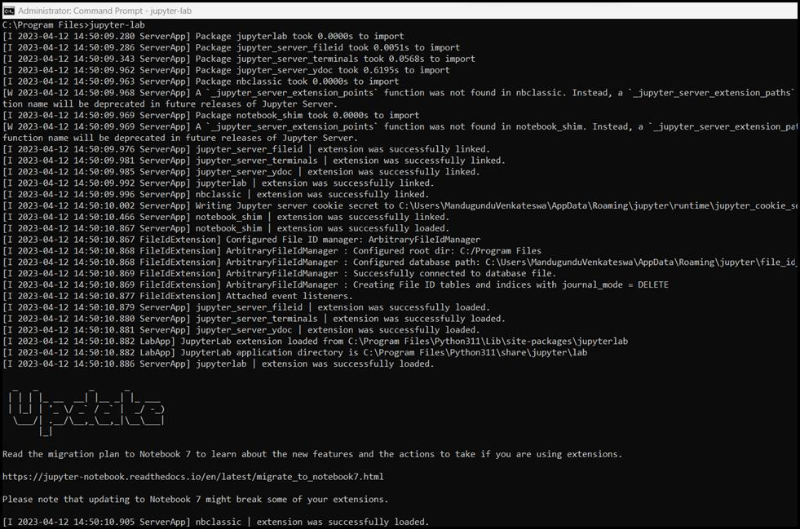
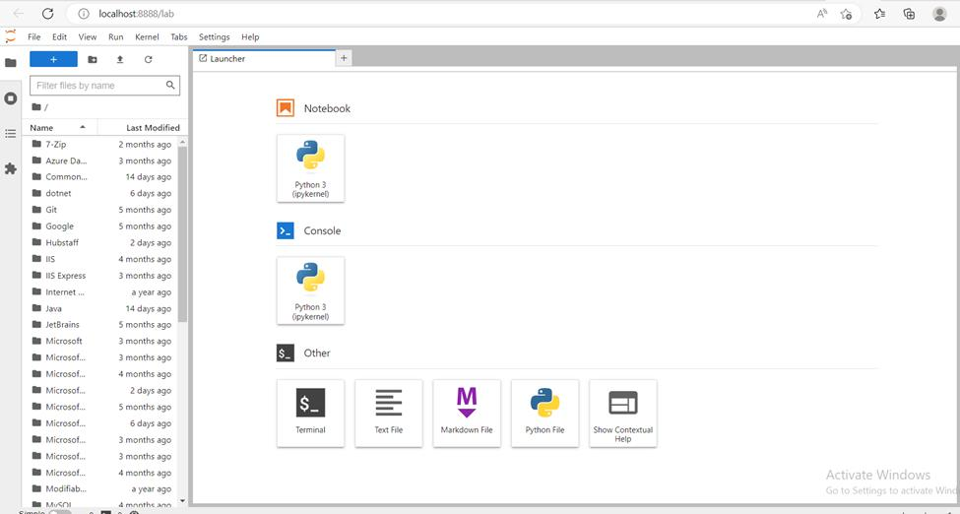

Exercise 1: Provisioning Azure OpenAI resource

Task 1: Create Azure OpenAI resource
- Open your browser, navigate to the Azure portal using https://portal.azure.com/. Login using your Azure credentials
- Click on Azure portal menu represented by three horizontal bars on the left side of the Microsoft Azure command bar as shown in the below image.
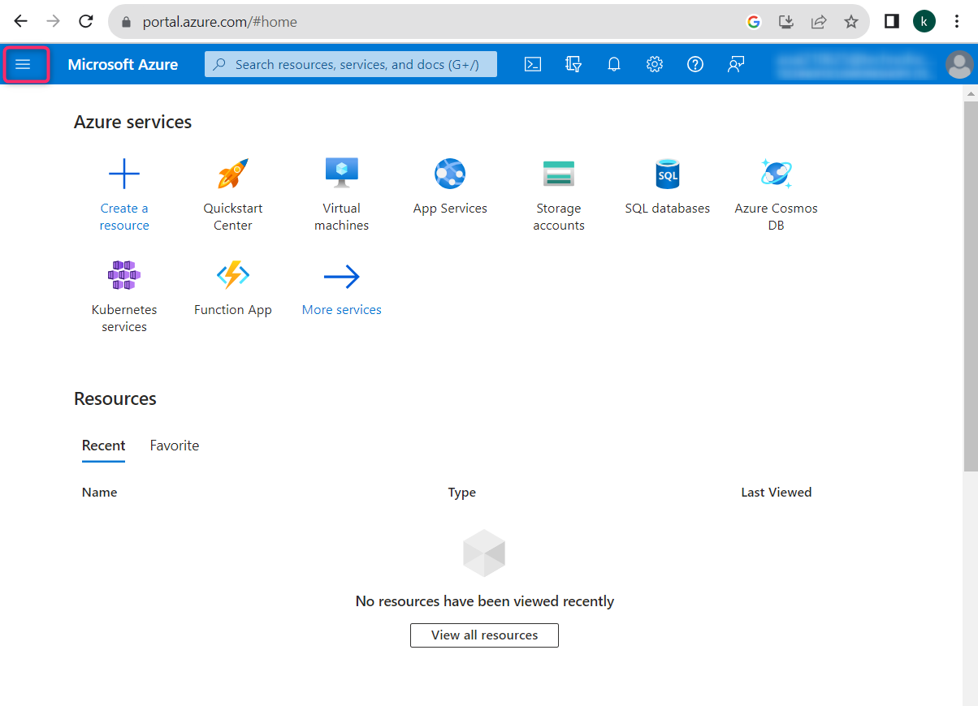
- Navigate and click on + Create a resource.
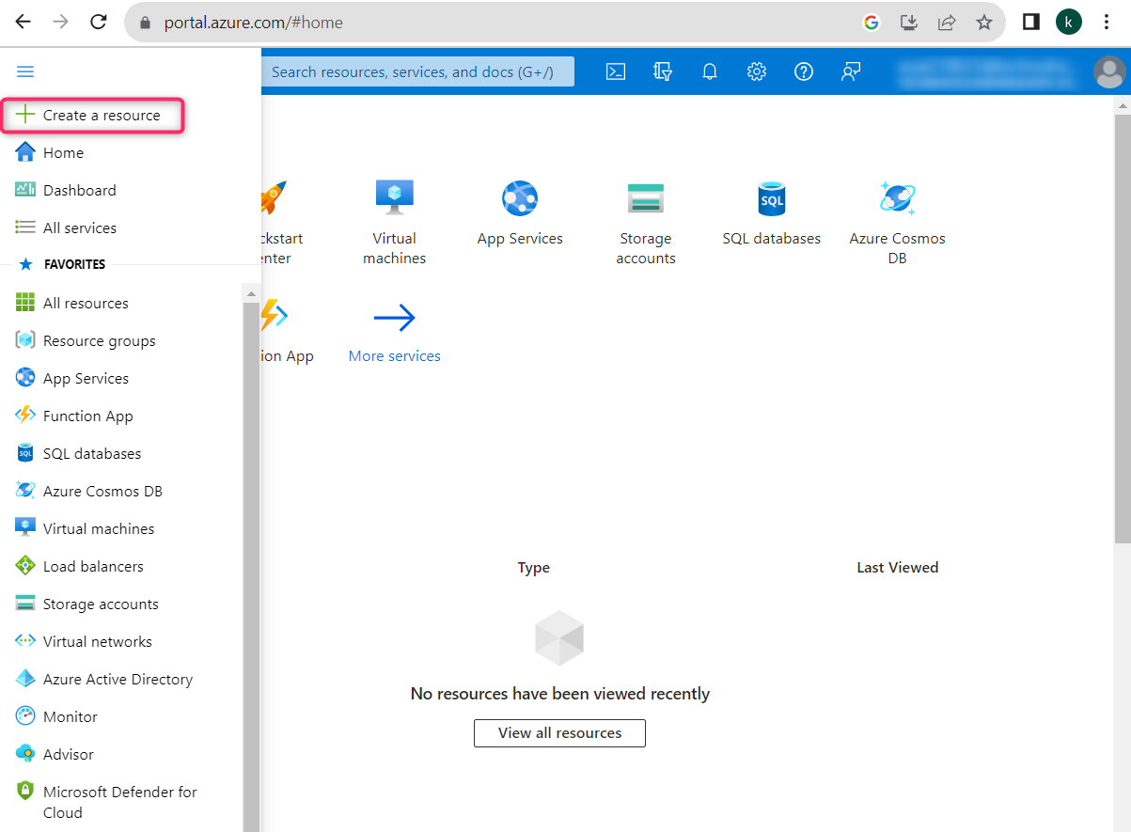
- On Create a resource page, in the Search services and marketplace search bar, type Azure OpenAI and select it.
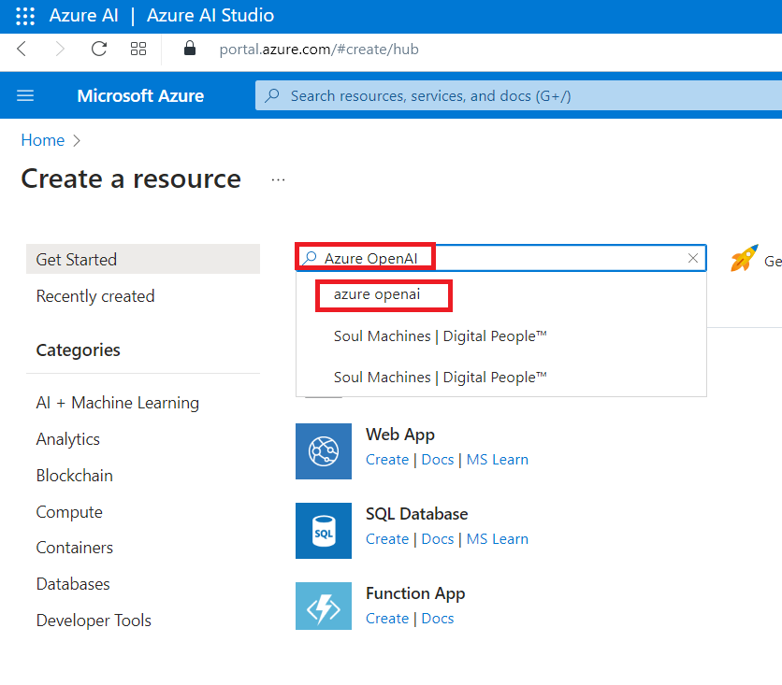
- In the Marketplace page, select Create -> Azure OpenAI .
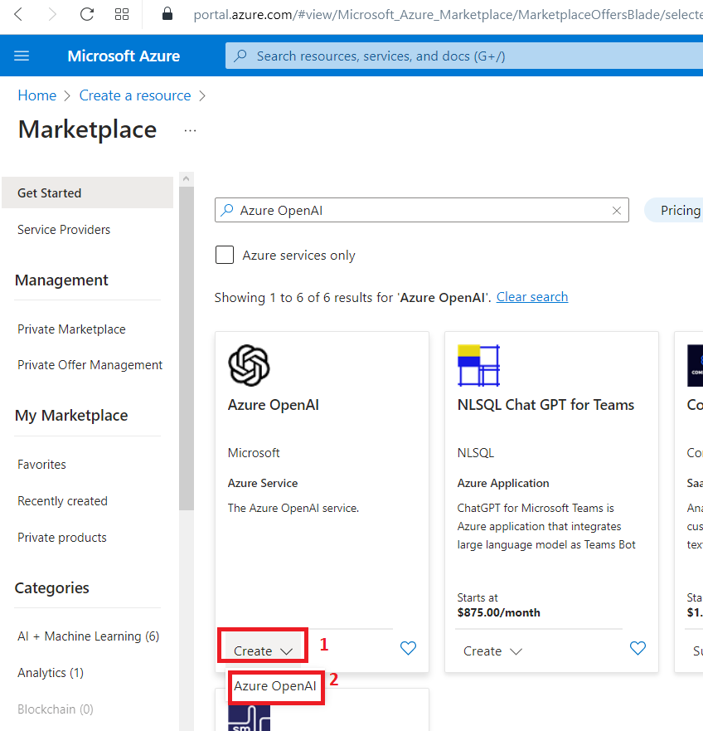
- In the Create Azure OpenAI window, under the Basics tab, enter the following details and click on the Next button.
  - Subscription: Select your subscription
  - Resource group: Select Create New. Type AzureOpenAIRG and click on OK.
  - Region: Select East US
  - Name: Azure-openai-testXX (XX can be a unique number) (here, we entered Azure-open-test29)
  - Pricing tier: Select Standard S0
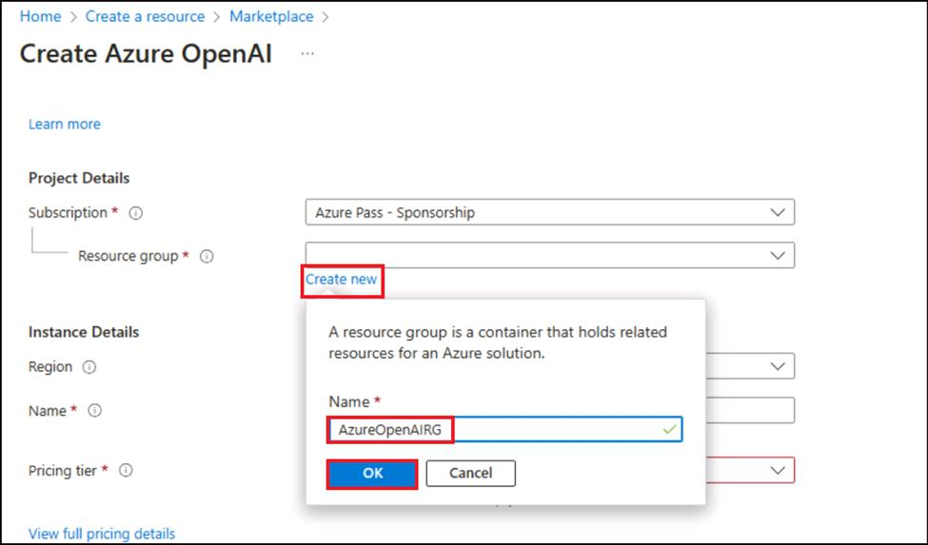
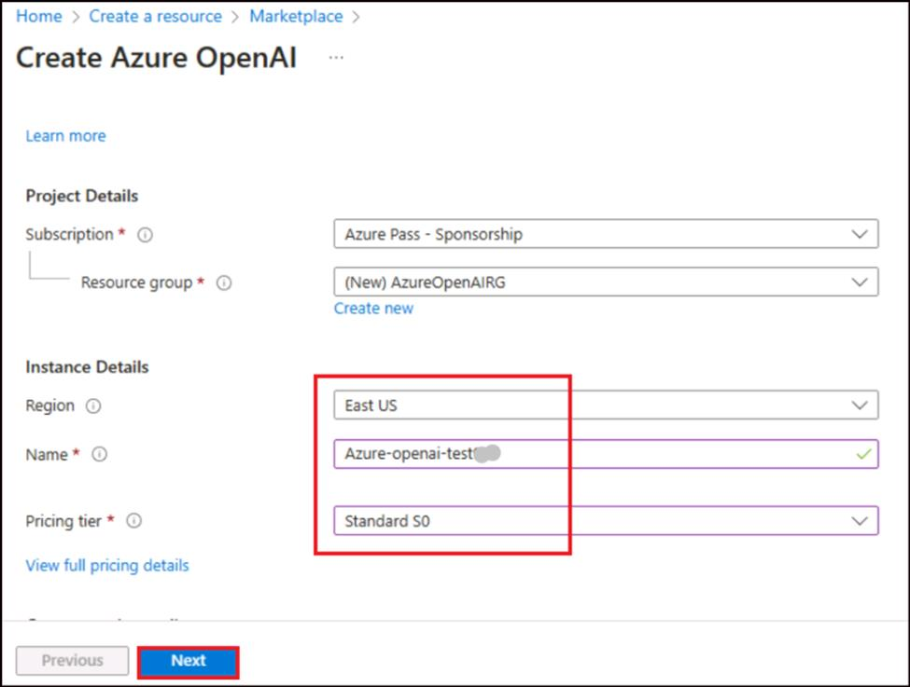
- In the Network tab, leave all the radio buttons in the default state, and click on the Next button.
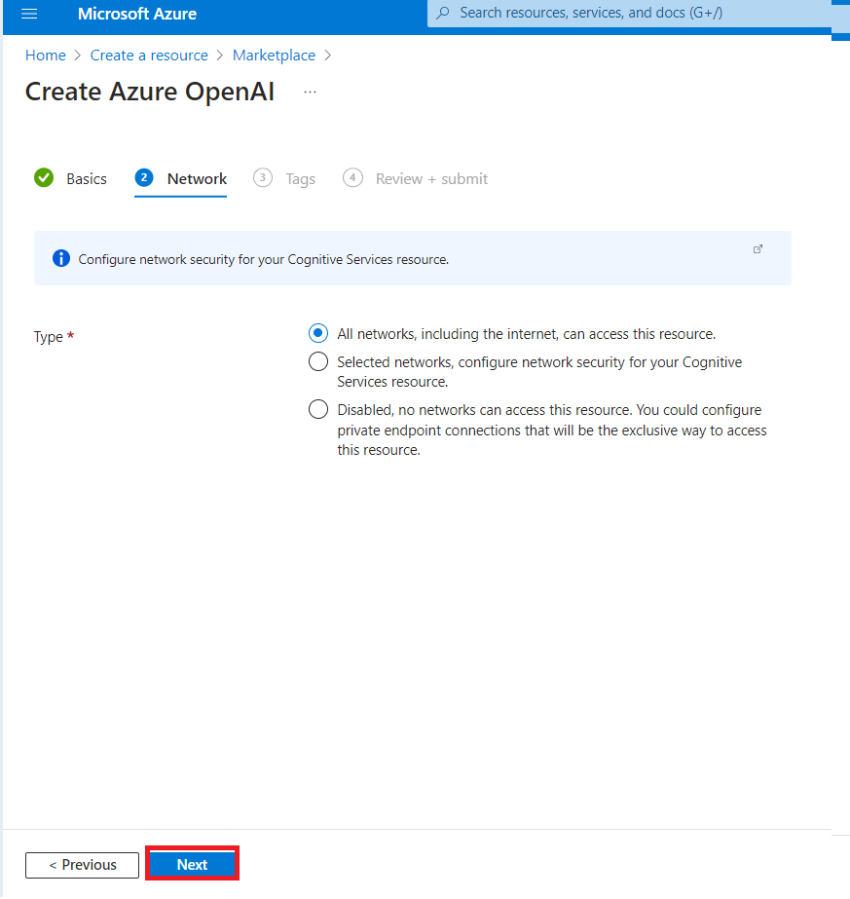
- In the Tags tab, leave all the fields in the default state, and click on the Next button.
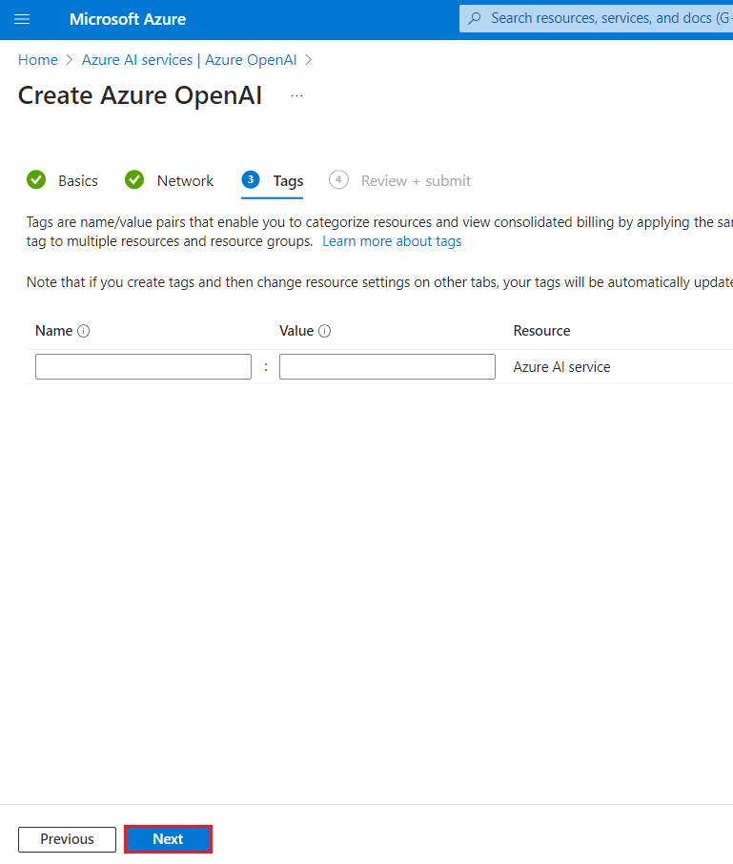
- In the Review+submit tab, once the Validation is Passed, click on the Create button.
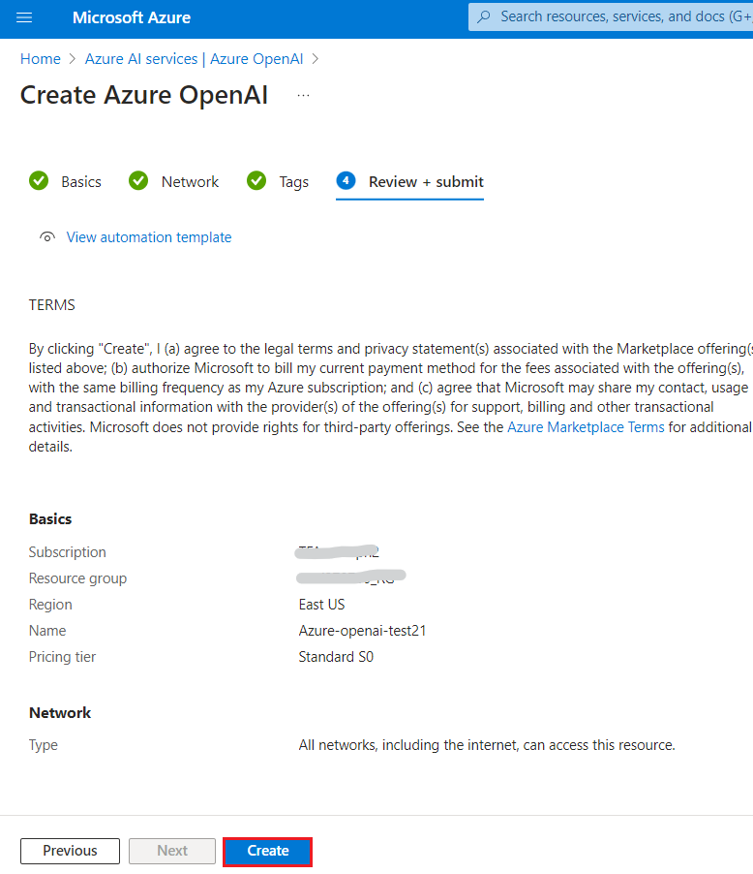
- Wait for the deployment to complete. The deployment will take around 10-15 minutes.
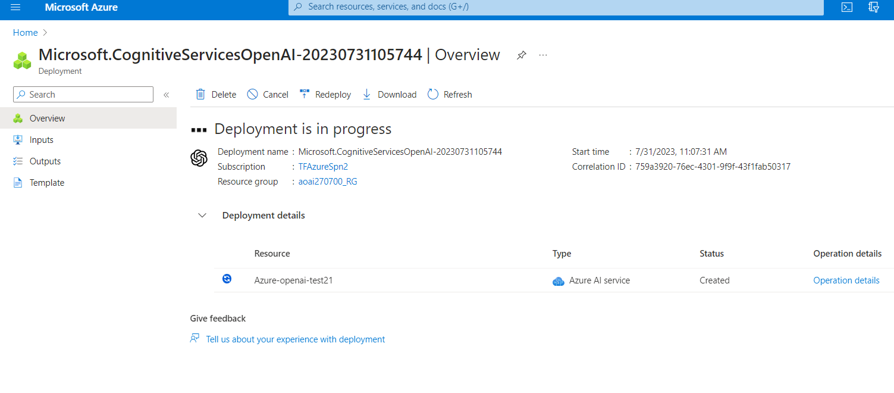
- On Microsoft.CognitiveServicesOpenAI window, after the deployment is completed, click on the Go to resource button.
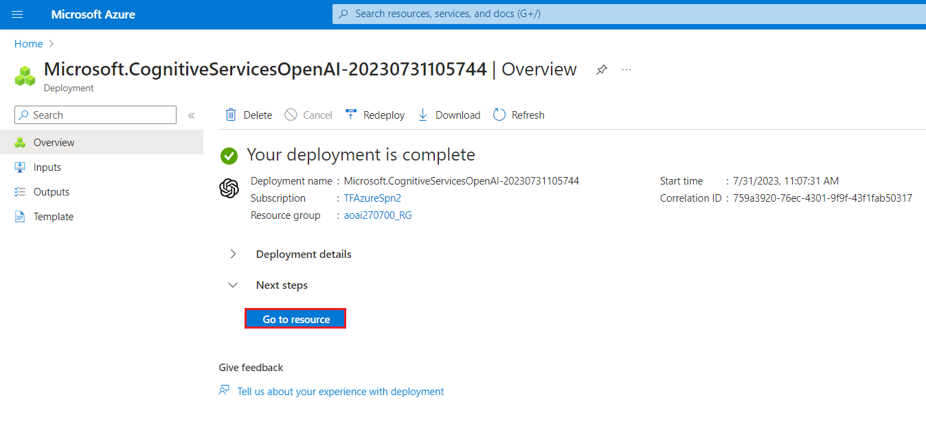
In this exercise, you’ve learnt how to create an Azure OpenAI resource in Azure OpenAI Studio.

Task 2: Retrieve the key and endpoint of Azure OpenAI service
- In your Azure-open-testXX | Model deployments window, navigate to the Resource Management section, and click on Keys and Endpoints.
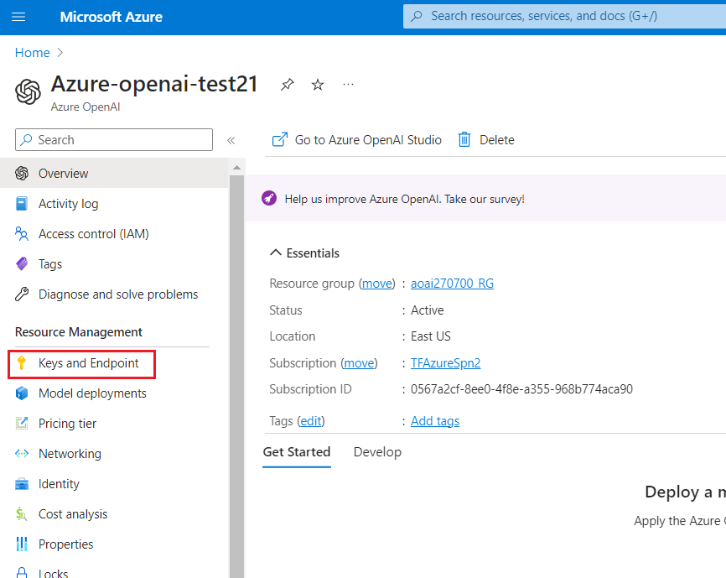
- In Keys and Endpoints page, copy KEY1, KEY 2, (You can use either KEY1 or KEY2) and Endpoint and paste them on a notepad (as shown in the image), and then Save the notepad to use the information in the upcoming lab.
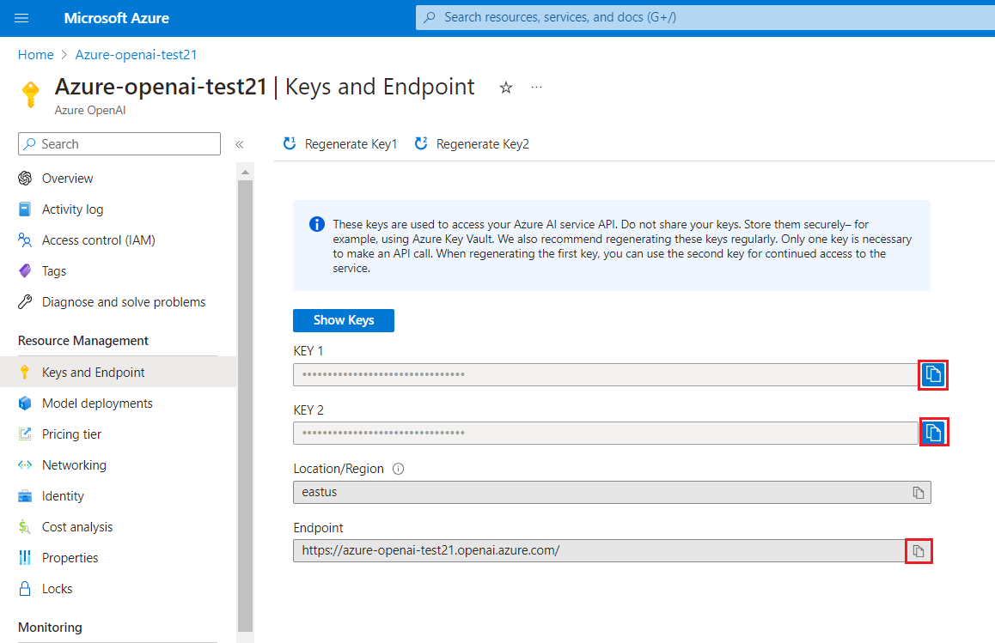
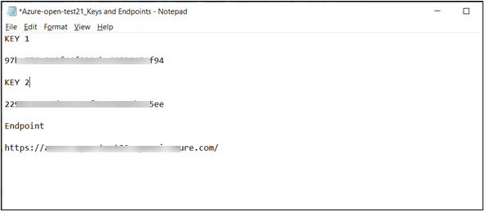
Note: You will have different KEY values.This value can be found in the Keys and Endpoint section when examining your resource from the Azure portal. You can use either KEY1 or KEY2. Always having two keys allows you to securely rotate and regenerate keys without causing a service disruption*.
Summary
In this exercise, you have provisioned an Azure OpenAI resource, retrieved the keys and endpoint information that will be used for deploying Azure OpenAI models in the upcoming labs.

Exercise 2: Generating the e-mail content

Task 1: Create models for gpt-35-turbo
- Open your Edge browser, navigate to the address bar, and paste the url https://oai.azure.com/ and press Enter.
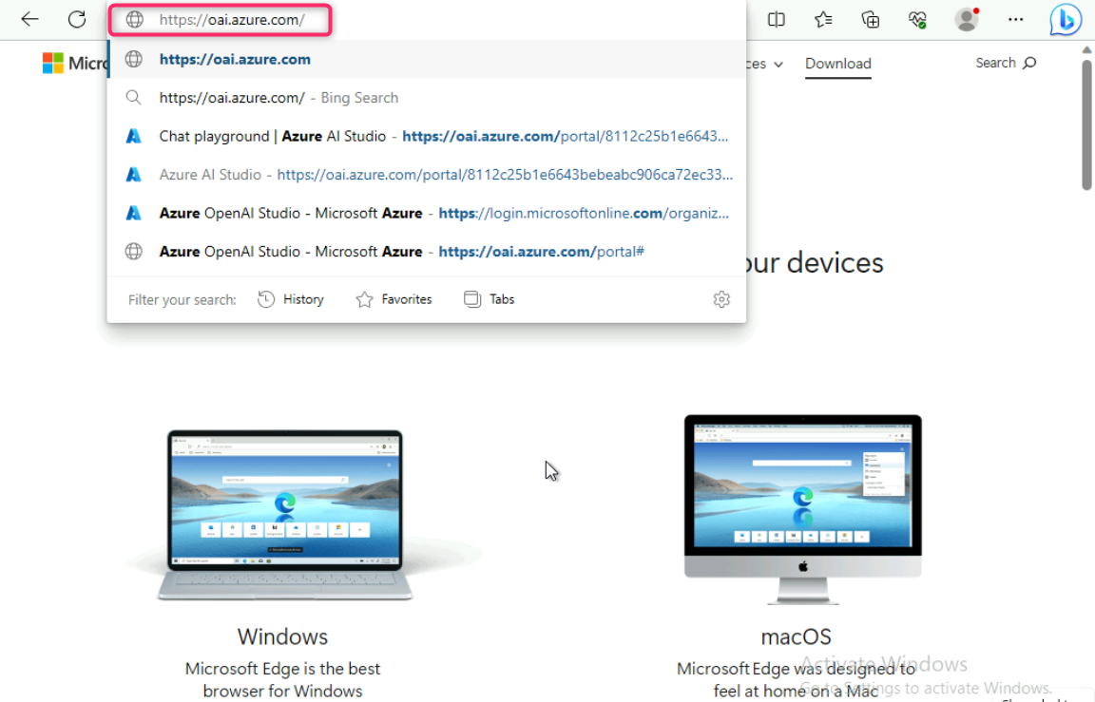
Note: If you are directed to the Azure OpenAI Studio home page, then skip steps #2 to #4, else continue.
- In the Microsoft Azure window, enter your Sign-in credentials, and click on the Next button.
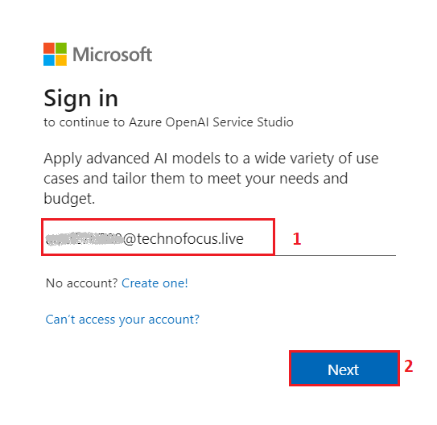
- Then, enter the password and click on the Sign in button**.**
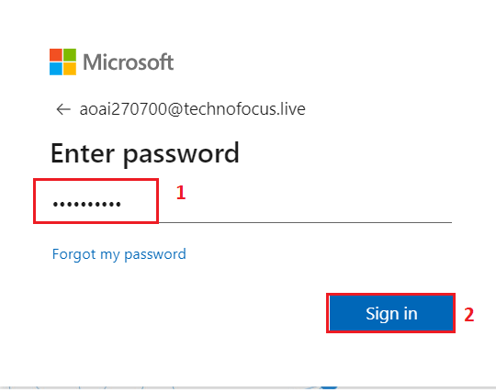
- In Stay signed in? window, click on the Yes button.
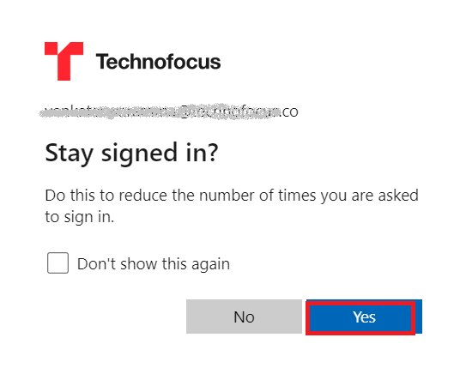
- On the Welcome to Azure OpenAI Studio dialog box, under the Subscription field, enter the subscription assigned to you, and in the Resource field, select the Resource name that you’ve created in Exercise #1, and then click on the Use resource button.
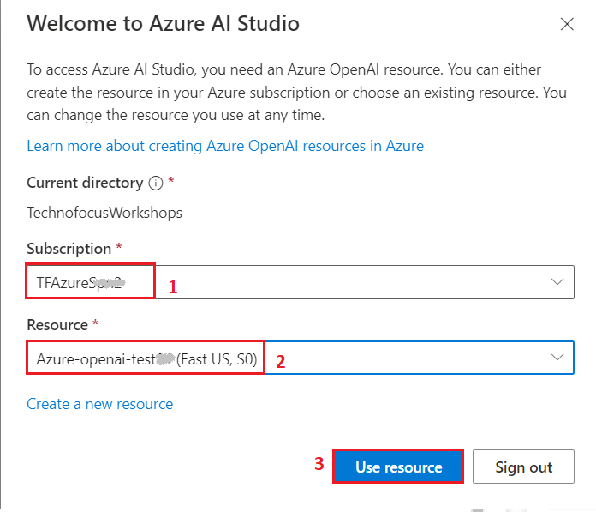
- Wait for the Azure OpenAI studio to launch.
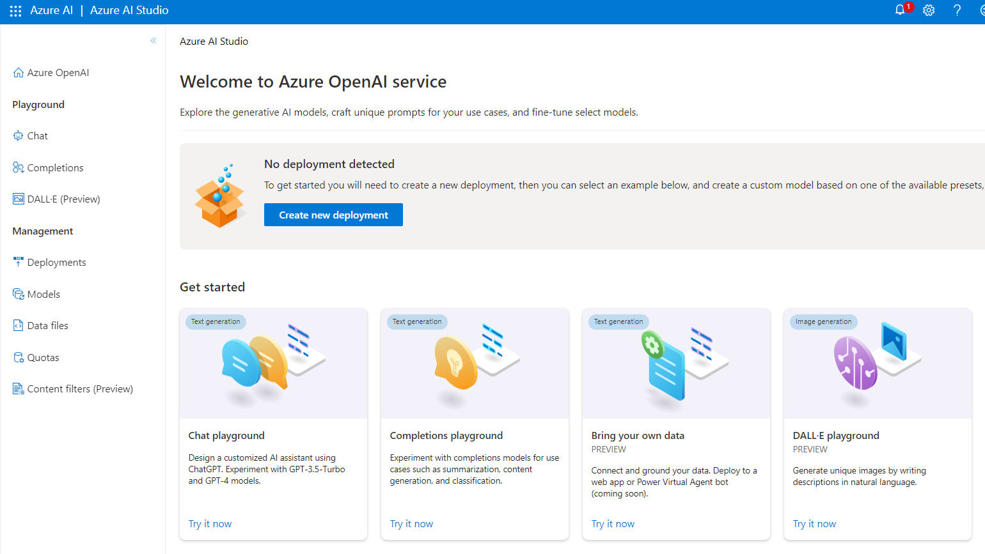
- On the Azure OpenAI Studio homepage, click on Create new deployment button.
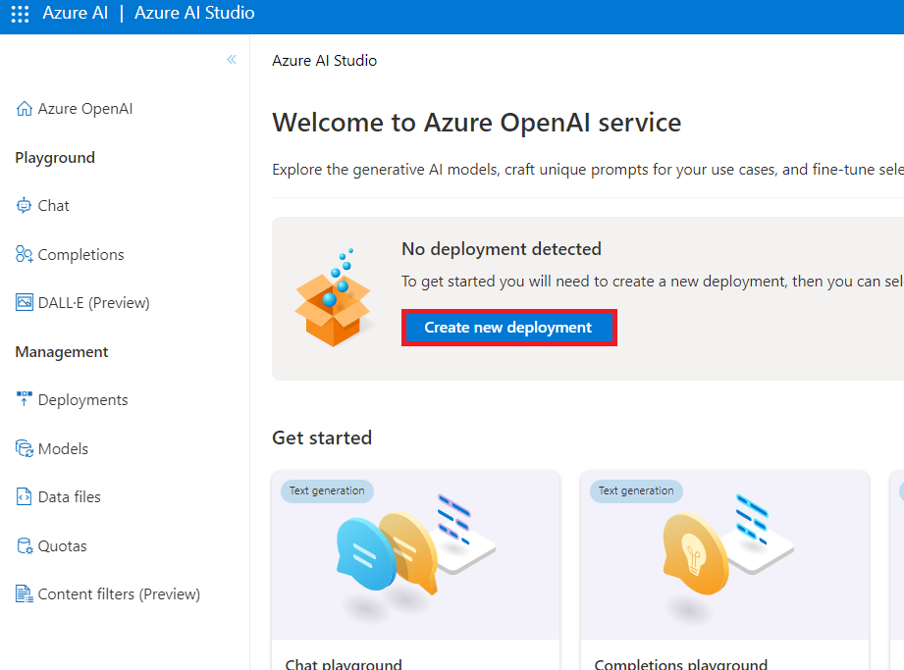
- In the Deployments page, click on +Create new deployment.
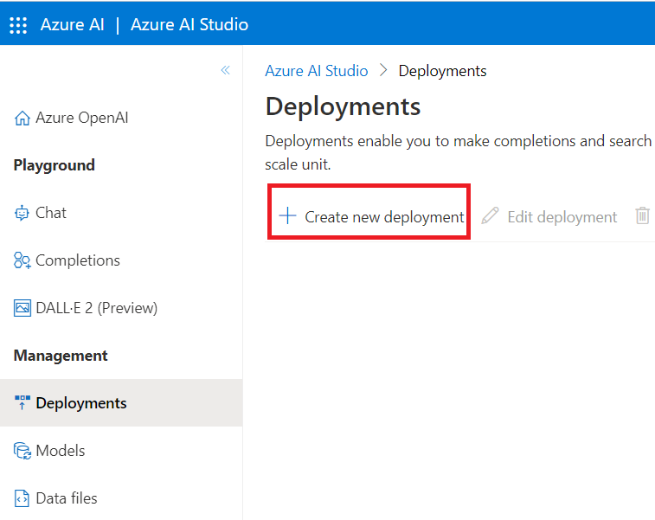
- In the Deploy model dialog box, under the Model name field, click on the V chevron button; navigate and select carefully gpt-35-turbo.
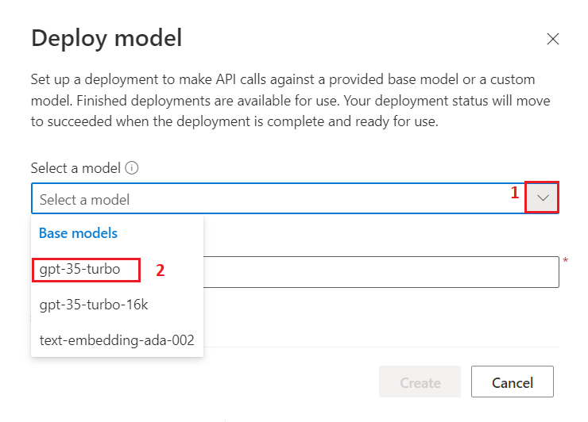
- Select the Model version as Auto-update to default, in the Deployment name field, enter gpt-35turbo, and click on the Create button.
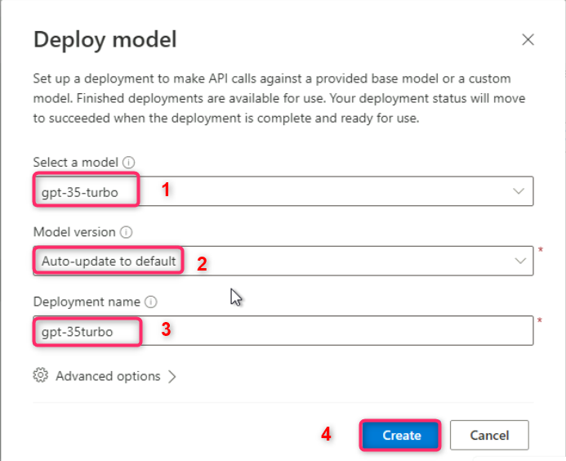
Note: Azure OpenAI includes multiple models, each optimized for a different balance of capabilities and performance. In this exercise, you’ll use the GPT-3.5-Turbo model, which is a good general model for summarizing and generating natural language and code. For more information about the available models in Azure OpenAI, see Models in the Azure OpenAI documentation.
- You will see a notification – Successfully Created deployment when the deployment is succeeded (You can also view the notification by clicking on the bell icon beside Azure AI | Azure AI Studio).
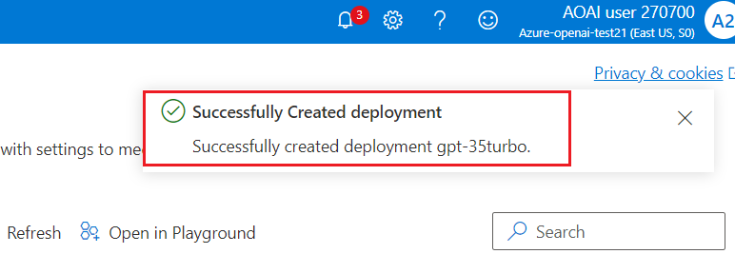

Task 2: Setup Parameters
- In your Windows search box, type Visual Studio, then click on Visual Studio Code.
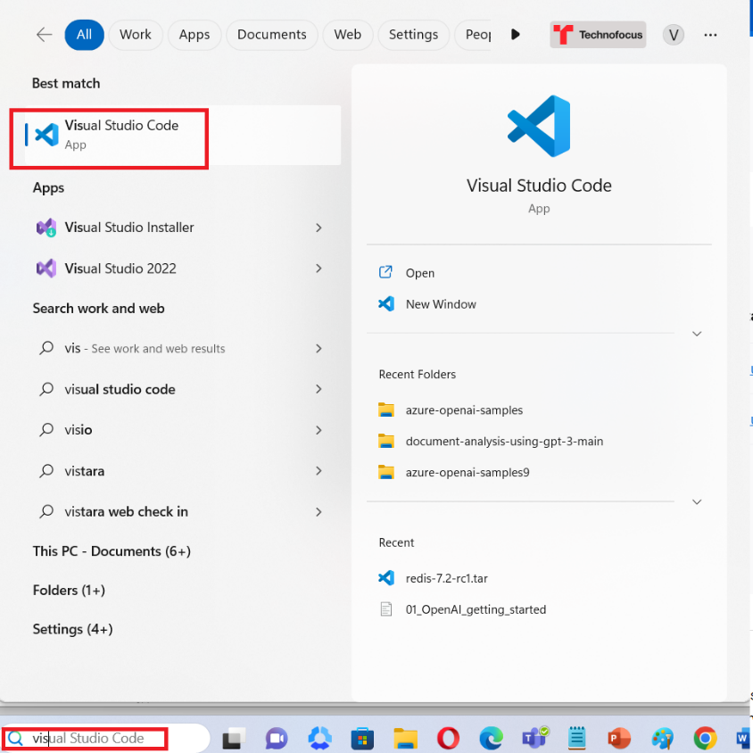
- In the Visual Studio Code editor, click on File, then navigate and click on Open File.
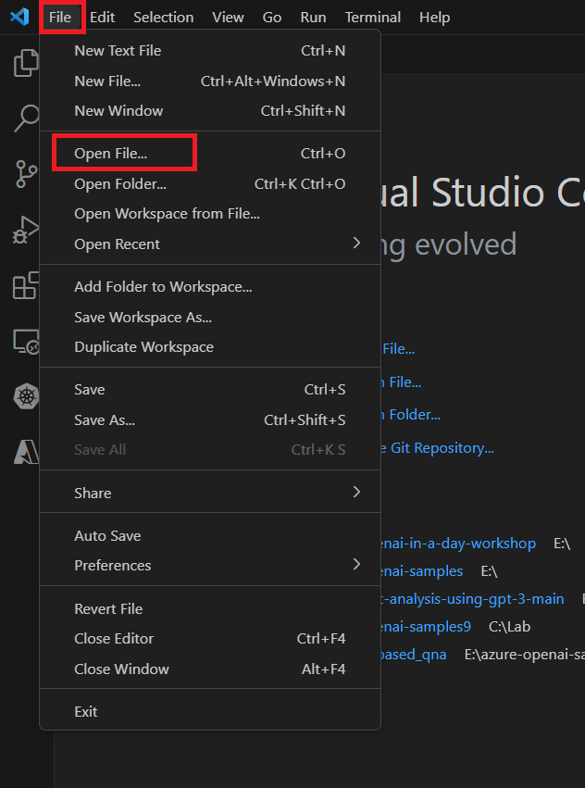
- Navigate and select email_response_generation.ipynb notebook from C:\LabFiles and click on the Open button.
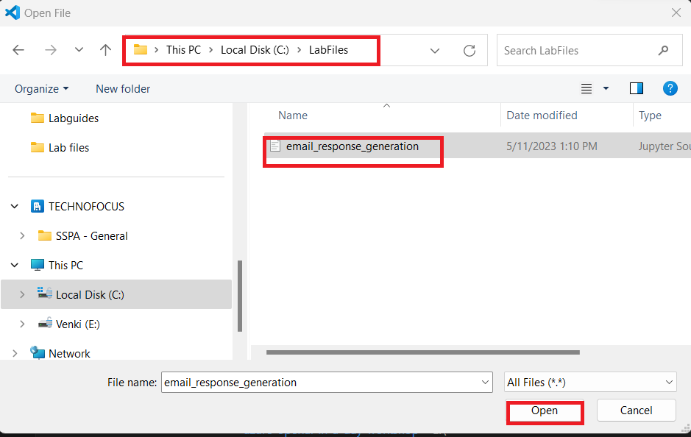
- In case, Do you want to allow untrusted files in this window? dialog box appears, then click on the Open button.
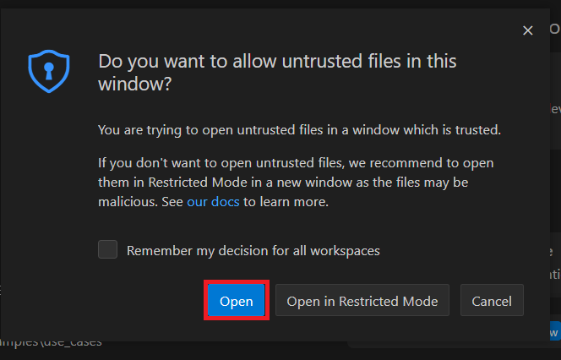
- In case, a notification stating Do you want to install the recommended extension for Python? appears, then click on the Install button.
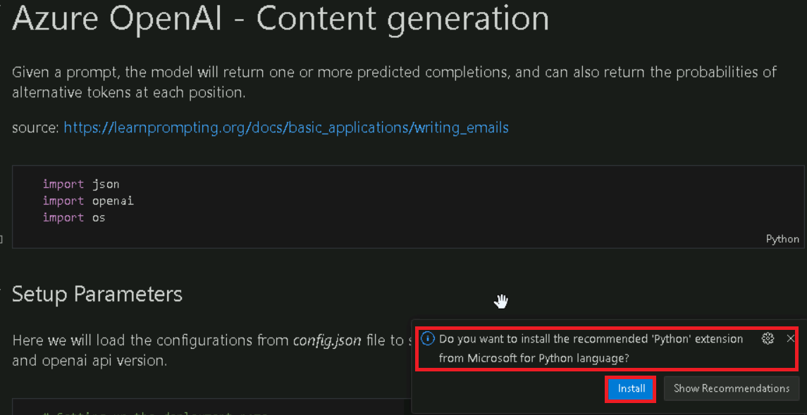
- After successfully installing the extension, click on the email_response_generation file.
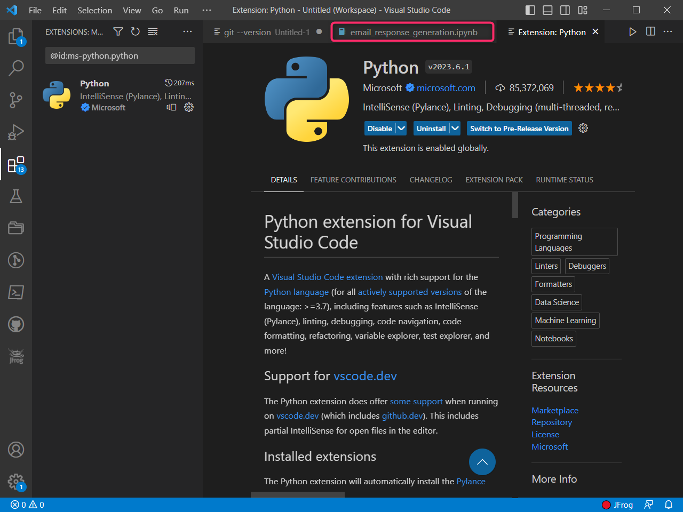
- Ensure that the Cell Language Mode is Python. In the first cell, click on Execute cell start icon as shown in the image.
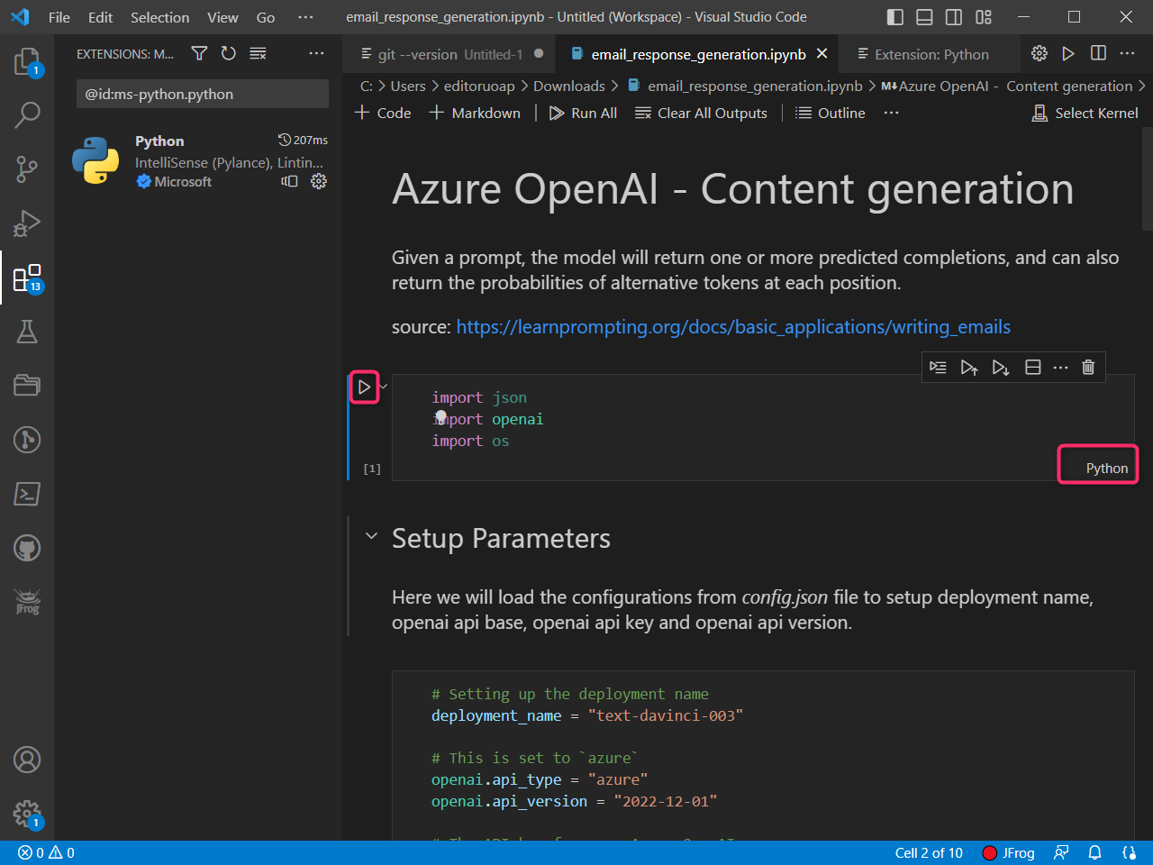
- If prompted to select the environment, then select Python Environments as shown in the image.
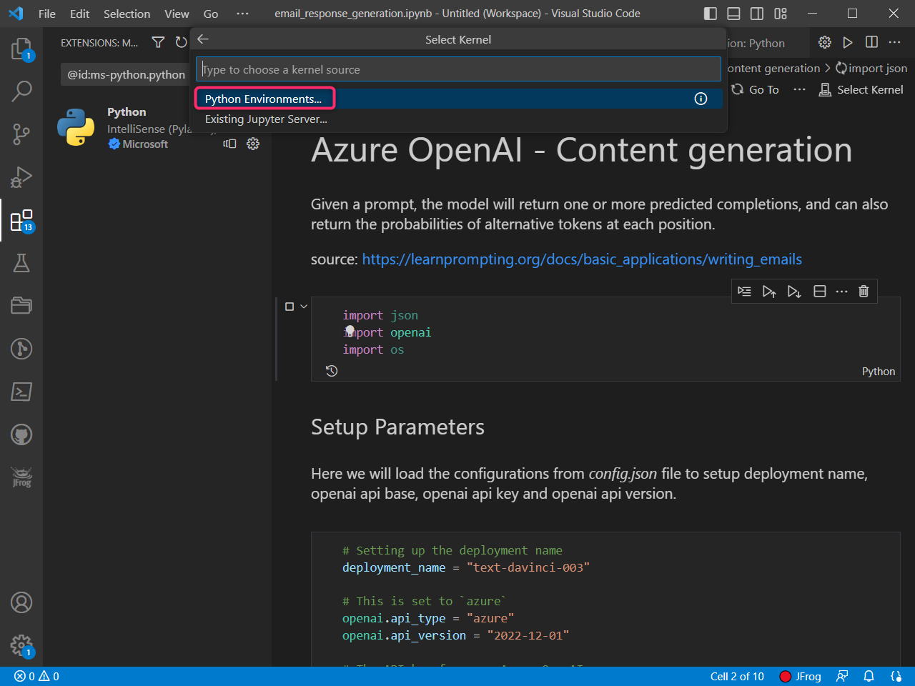
- If prompted to select the path, then select the Python version you had installed path as shown in the image.
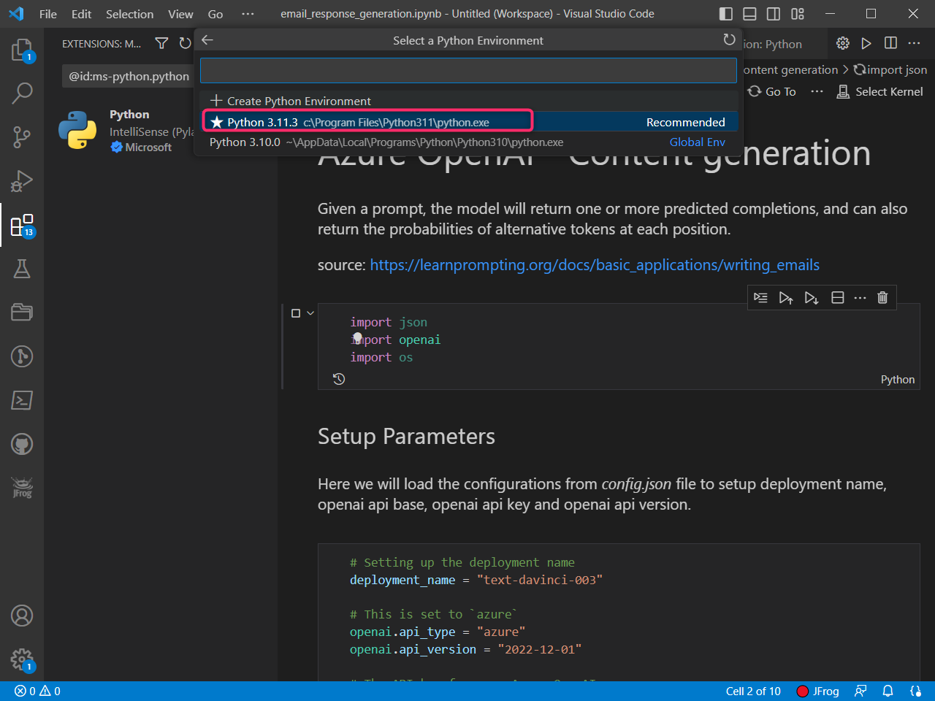
- In case, the Windows Security Alert dialog box appears, then click on Allow access button.
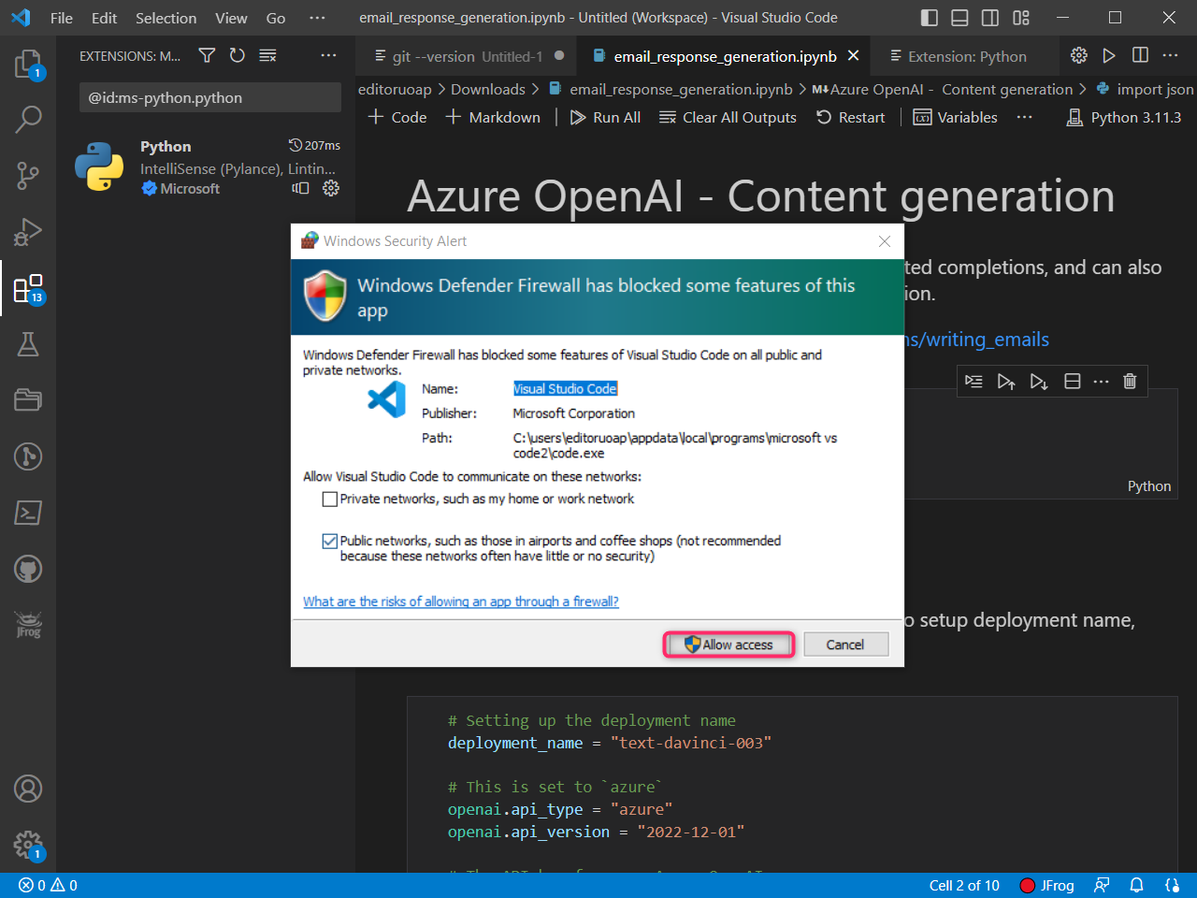
- In the second cell(Setup Parameters) of the Notebook, ensure that the below updates are made and then execute the cell by clicking on the Start icon.
Property | Value
deployment_name | gpt-35turbo
API_KEY | Your API Key that you had saved earlier in this lab.
RESOURCE_ENDPOINT | Your resource Endpoint value that you had saved earlier in this lab
Openai.api_version | 2023-03-15-preview
- Note: Update the Key value and Endpoint with the values that you have saved on your notepad in the in Lab #1
- 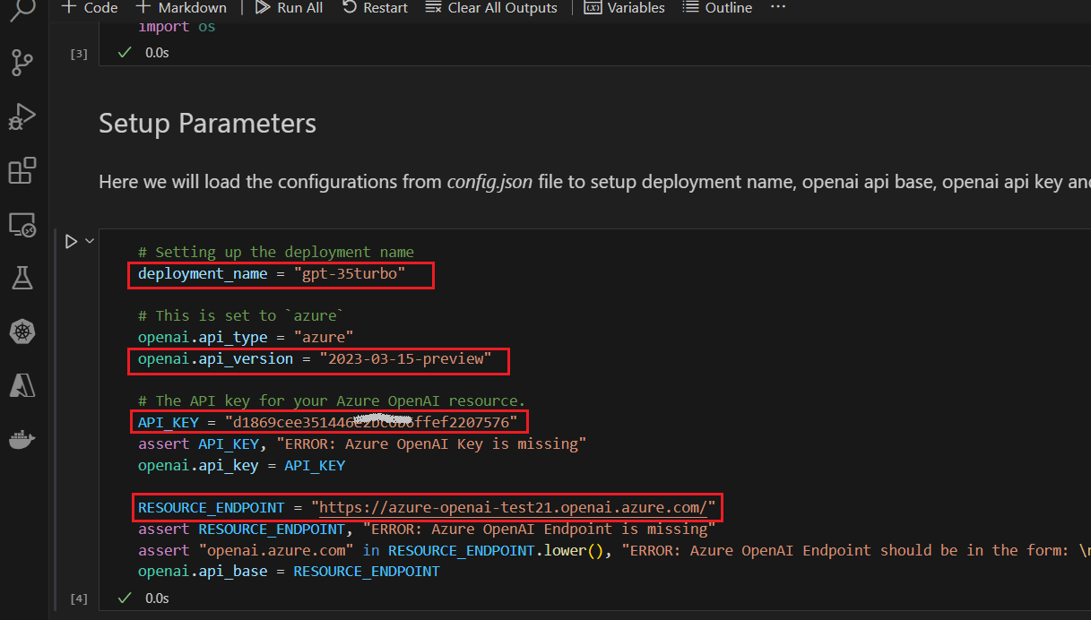
- Similarly, execute the rest of the cells.
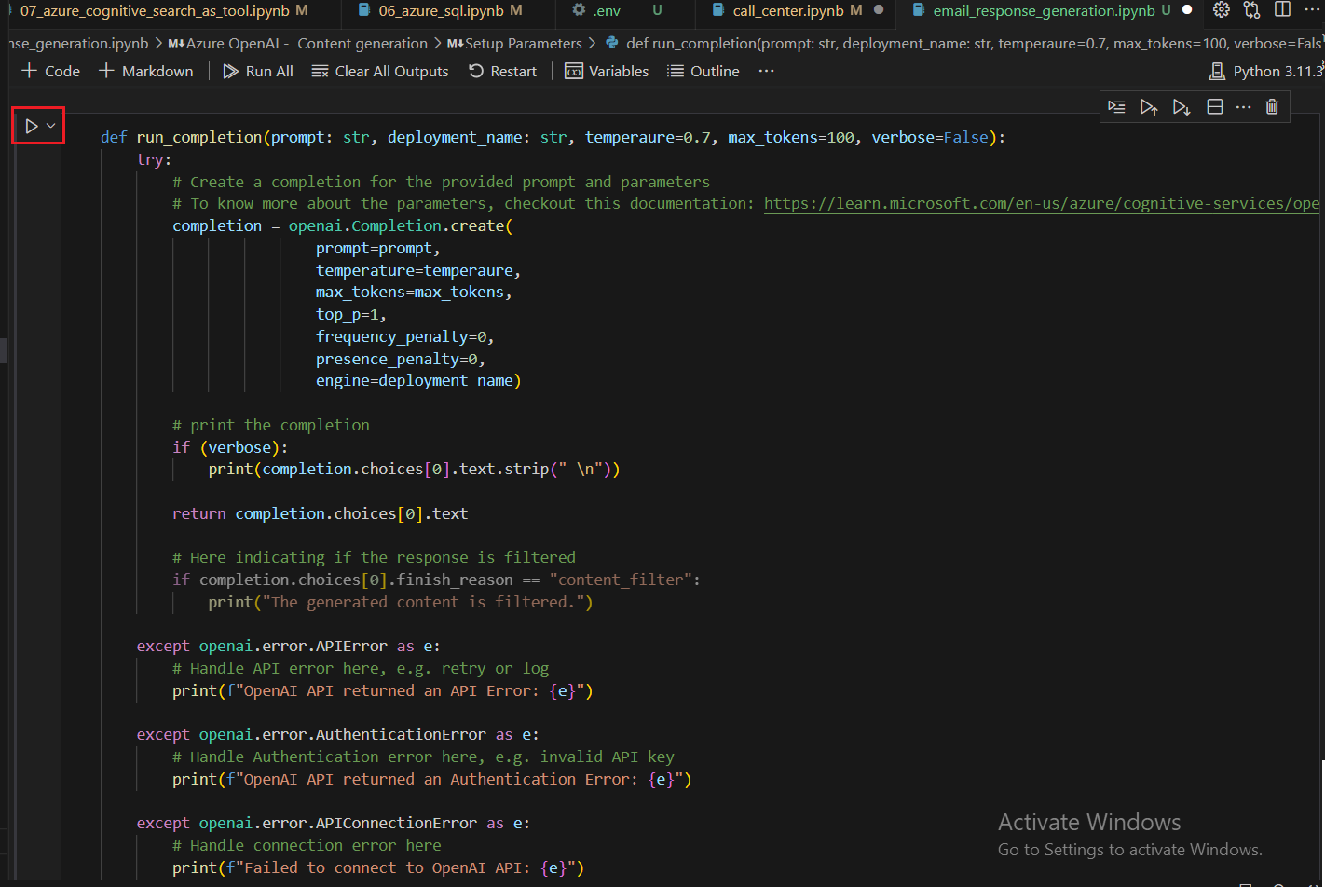
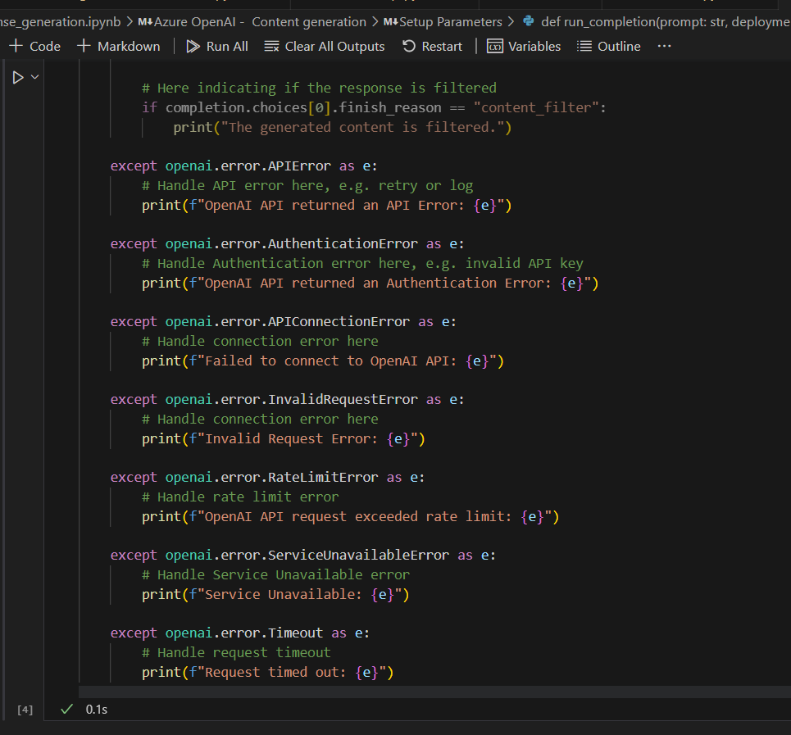
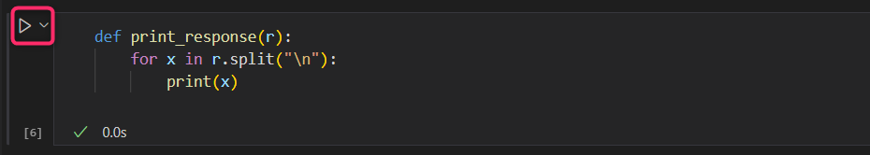

Task 3: Responding to an Email
Two-way/two-hop approach:
- Generate summary and action points.
- Generate a reply based on the summary and action points.
- Click on the start icon to execute the first prompt cell and read the response.
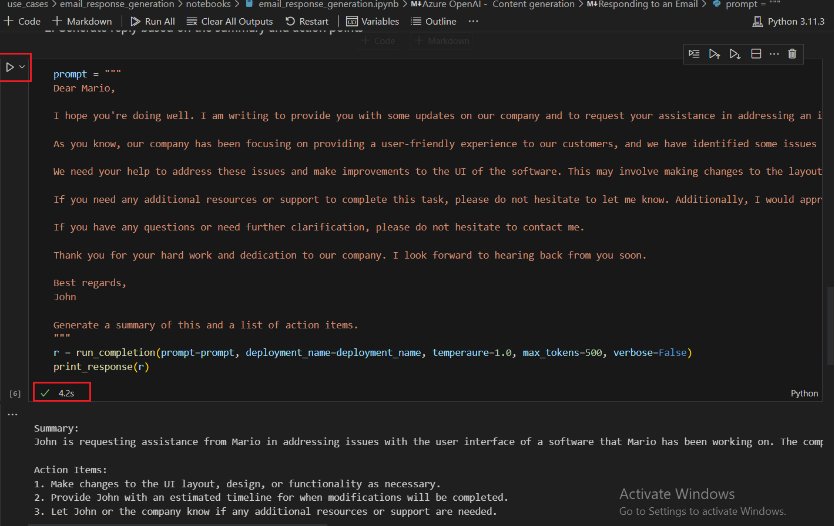
- Similarly, click on the start icon to execute the second prompt cell and read the response.
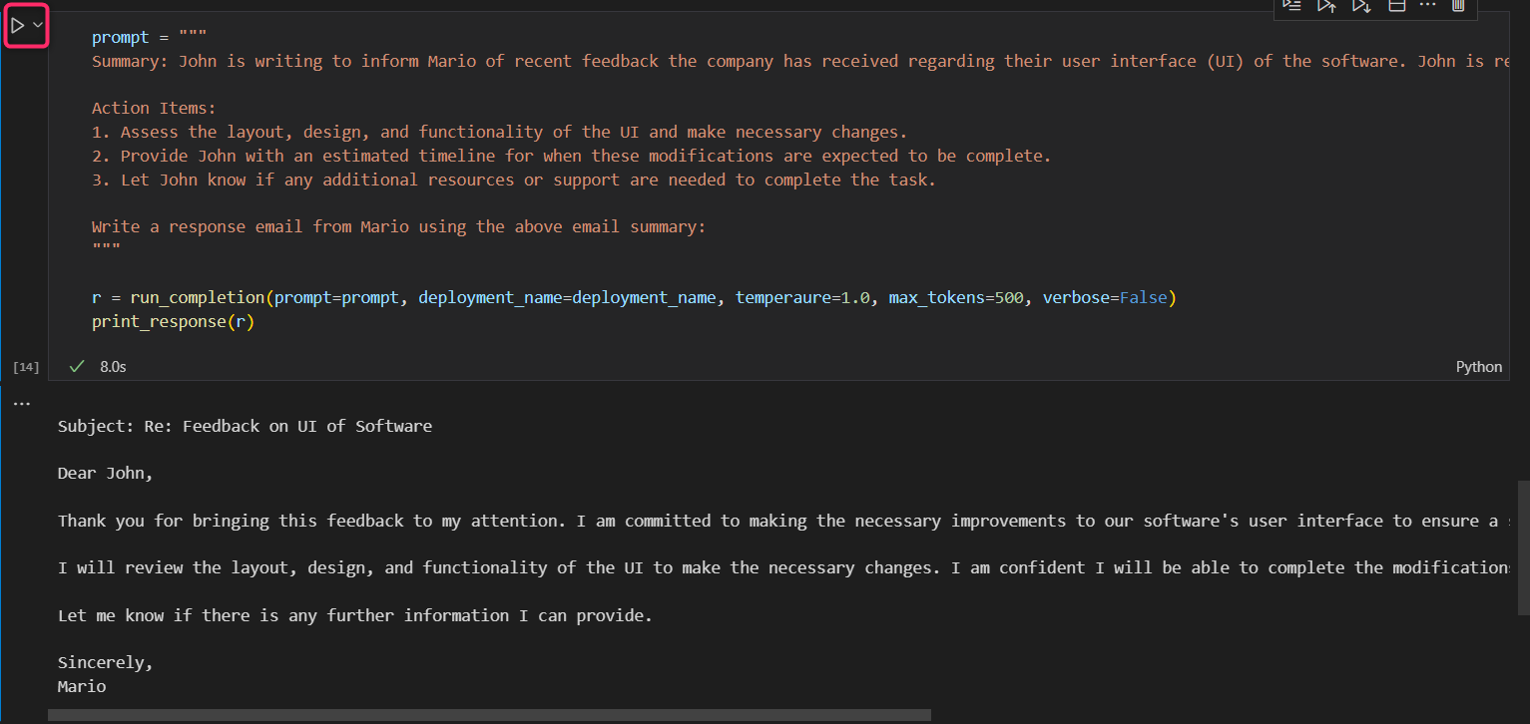

Exercise 3: Delete the Deployed Model
- In Azure OpenAI Studio, on the left pane, under the Management section, click on Deployments.
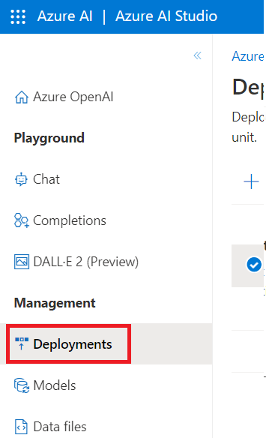
- Select gpt-35turbo deployment name and click on Delete deployment.
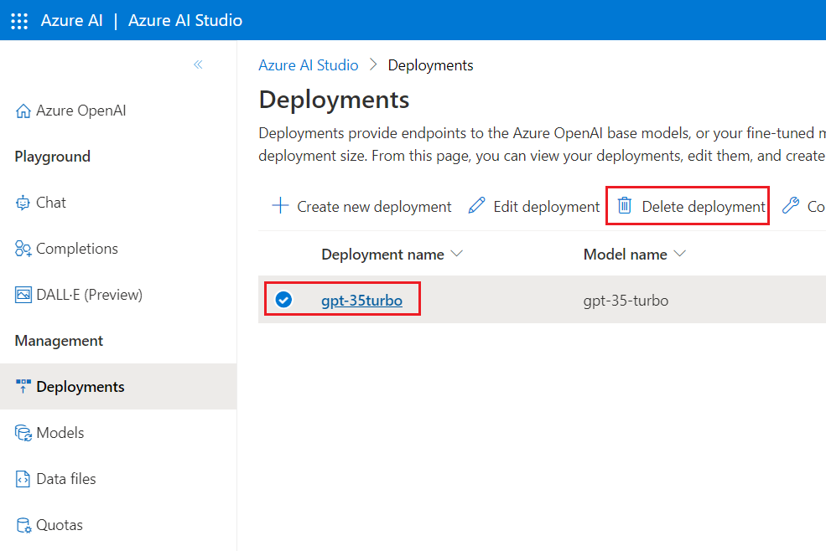
- In the Confirm delete dialog box, click on the Delete button. You will see the notification – Successfully Deleted deployment (In case, you did not see the notification, then click on the bell icon beside Azure AI|Azure AI Studio).
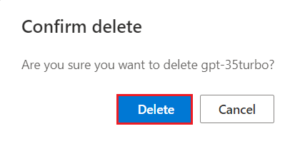
Summary
In this lab, you’ve used an email_response_generation notebook in Visual Studio Code, set up the parameters, and generated a response to an email using Azure AI Studio gpt-35-turbo model.

